UNIGLOBE COLLEGE
(Affiliated to Pokhara University)
New Baneswor, Kathmandu



Fourth Semester Project Report On
“Click2Eat – Canteen Pre-order system”
(PRJ181)

A Fourth Semester Project Report on the partial fulfillment of the requirement of bachelors of computer science and information technology

Under the supervision of
Annu Khanna Nakarmi
Lecturer/Supervisor

Submitted By:
Shulabh Shrestha
Raja Mandal
Aaishwarya Prashant
Saistha Pradhan

Submitted To:
UNIGLOBE COLLEGE
Department of Computer Science and Information Technology
New Baneswor, Kathmandu, Nepal
May, 2026

“Click2Eat – Canteen Pre-order system”
(PRJ181)

A fourth semester project report submitted in partial fulfillment of the requirements for the degree of Bachelor of Computer System and Information Technology awarded by Pokhara University

Submitted By
Shulabh Shrestha
Raja Mandal
Aaishwarya Prashant
Saistha Pradhan

Submitted To
UNIGLOBE COLLEGE
Department of Computer Science and Information Technology
New Baneshwor, Kathmandu, Nepal
May 2026

Abstract

The Canteen Pre-order System is a web application built to streamline and revolutionize the food ordering procedure at a college canteen, making it easier for students to order food online without standing in line, wasting precious time. This application will allow students to create a user account, log in, choose from the menu options, browse specials of the day, check which products are sold out, and order instantly using a one-click option without having to go through the hassle of filling a shopping cart. After placing the order, users will be able to see its current status, which includes Pending, Preparing, Ready for Pick-Up, and Payment Made and Order Completed. Besides, students can track their past orders and refer back to them when needed. From the admin's perspective, the system will offer a dashboard where canteen employees can manage the menu items, add new food products, edit their descriptions, remove items that are no longer offered, update item availability, mark some products as sold out, and easily handle incoming orders. The project uses a well-organized relational database, including tables for students, admins, menu items, orders, and completed orders.

TABLE OF CONTENTS

Abstract 2
TABLE OF CONTENTS 1
LIST OF FIGURES 3
ABBREVIATIONS 4
CHAPTER 1: INTRODUCTION 1
1.1 Background 1
1.2 Problem Statement 2
1.3 Objectives of the Project 2
1.4 Scope of the Project 2
1.5 Limitations of the Project 3
1.6 Significance of the Study 3
CHAPTER 2: LITERATURE REVIEW 4
2.1 Overview 4
2.2 Review of Existing Systems 4
2.2.1 QR-Based Canteen System 4
2.2.2 Android-Based Canteen Ordering System 5
2.2.3 Smart Canteen Management System 5
2.3 Research Gap 6
CHAPTER 3: SYSTEM ANALYSIS AND DESIGN 7
3.1 Project Management Strategy and Development Tools 7
3.1.1 Project Team 7
3.1.2 Project Flow and Schedule 7
3.1.3 Responsibilities 7
3.1.4 Development Tools 8
3.2 System Analysis 9
3.2.1 Requirement Analysis 9
3.2.2 Feasibility Analysis 10
3.3 System Design 11
3.3.1. Activity Diagram 11
3.3.2 ER Diagram 12
3.3.5 Use Case Diagram 12
3.3.6 Sequence diagrams 13
3.3.7 Database Schema Diagram 13
References 14

LIST OF FIGURES
Figure 1: Activity Diagram 11
Figure 2: ER Diagram 12
Figure 3: Use case diagram 12
Figure 4: Sequence diagram 13
Figure 5: Class Diagram 13

ABBREVIATIONS
CSS  HTML  JS  SQL  PHP  XAMPP | Cascading Style Sheet  Hyper Text Markup Language  JavaScript  Sequence Query Language  Hypertext Preprocessor  Cross-Platform (X), Apache (A), MariaDB (M), PHP (P), and Perl (P)

CHAPTER 1: INTRODUCTION

Background
The traditional canteen system used in many colleges and educational institutions often relies on manual food ordering, where students must physically visit the canteen, stand in long queues, check food availability directly at the counter, place orders verbally, and wait for preparation before collecting their meals. This process is often inefficient, especially during peak hours such as lunch breaks, when a large number of students attempt to order food simultaneously. As a result, overcrowding, time wastage, order confusion, delayed service, and inaccurate communication regarding food availability are common challenges. Students may spend a significant portion of their limited break time waiting in line, only to discover that their desired food item is unavailable or sold out. Similarly, canteen staff often face operational pressure in managing multiple orders manually, handling repeated food availability inquiries, and maintaining smooth service flow. These limitations highlight the growing need for a more efficient and technology-driven solution.

With the rapid advancement of web technologies and increasing digital adoption in educational environments, web-based management systems have become practical tools for improving operational efficiency across various institutional services. Digital solutions have already transformed systems such as online admissions, e-learning platforms, digital libraries, and fee management, making processes faster, more transparent, and user-friendly. However, canteen services in many institutions still operate using outdated manual systems. Introducing a Digital Canteen Pre-order System aligns with the broader movement toward digital transformation by modernizing the food ordering experience through automation and real-time information management.

The Digital Canteen Pre-order System is designed as a web-based platform that enables students to browse available food items digitally, check daily menus, identify Today’s Special dishes, and view sold-out items before placing an order. Unlike conventional e-commerce food ordering systems that rely on multi-item shopping carts, this project focuses specifically on a simplified one-click ordering approach, where students can instantly pre-order a single food item for quick service. This targeted design choice is particularly suitable for college canteens, where speed, convenience, and reduced complexity are essential. By minimizing ordering steps, the system ensures that students can place orders quickly during short academic breaks while avoiding unnecessary interface complications.

1.2 Problem Statement
Traditional college canteen systems often depend on manual food ordering processes that cause long queues, time wastage, overcrowding, and inefficient service during peak hours. Students frequently face difficulties in checking food availability, placing orders quickly, and receiving timely updates on order status, while canteen staff struggle with managing multiple orders and updating menu availability efficiently. These limitations create inconvenience for both students and administrators, highlighting the need for a digital pre-order system that simplifies food ordering, improves service speed, and enhances overall canteen management.

1.3 Objectives of the Project
The Objectives of the Project are as follows:
- To enable quick and easy pre-ordering of food for students
- To enable admins to manage menu items, food availability, and real-time order processing
- To provide clear tracking of order status

1.4 Scope of the Project
The Scope of the project are as follows:
- Digital menu with admin-controlled “Today’s special”
- One click ordering system with confirmation or undo and real time order status tracking
- Admin dashboard to manage orders, mark items as sold out and update “Paid and collected”

1.5 Limitations of the Project
The project has its limitations which are the things that it doesn’t include, they are:
- The system currently only supports single-item one click ordering, limiting students from ordering multiple food items in one transaction.
- Payment is handled physically during food collection, as online payment integration is not included
- The platform is designed primarily for single canteen environment, making it less suitable for managing multiple branches or larger-scale food service operation without future expansion

1.6 Significance of the Study
This study is significant because it helps improve traditional canteen systems by reducing long queues, saving time, and enhancing food service efficiency through digital automation. Similar studies have shown that smart canteen systems improve operational management, user convenience, and institutional service quality [1, 2, 3]. This project specifically provides a simplified one-click pre-order solution for educational institutions, making food ordering faster for students while supporting better menu and order management for canteen administrators.

CHAPTER 2: LITERATURE REVIEW

2.1 Overview
With the rapid advancement of digital technologies, traditional manual systems in various domains are being replaced by automated and efficient solutions. In educational institutions, canteen services still largely depend on manual ordering processes, which often result in long queues, delays, and inefficient management. To address these issues, several digital canteen and food ordering systems have been proposed in previous studies. This section reviews some of the existing systems and identifies their limitations.

2.2 Review of Existing Systems

2.2.1 QR-Based Canteen System
One of the widely proposed approaches is the QR-Based Canteen System developed by Joshi, S., Kasaju, B., Karki, P., Aryal, S. K., & Chhetri, S. B. [1]. This system uses Quick Response (QR) codes to provide users with access to the digital menu. Students can scan the QR code using their mobile devices, view available food items, and place orders electronically. The main advantage of this system is that it reduces physical interaction and eliminates the need for printed menus or manual order-taking.
Additionally, the QR-based approach helps in minimizing crowding at the ordering counter and supports a more hygienic environment. It is especially useful in situations where contactless services are preferred. However, despite these advantages, the system introduces certain usability challenges. Users are required to scan the QR code every time they want to access the menu, which adds an extra step and may not be convenient for frequent use.
Furthermore, the system lacks real-time order tracking capabilities, making it difficult for users to determine whether their order is being prepared or is ready for collection. The absence of a simplified ordering mechanism also affects the overall efficiency of the system. These limitations indicate that although QR-based systems improve accessibility, they do not fully address the need for speed and simplicity in a campus environment.

2.2.2 Android-Based Canteen Ordering System
Another commonly proposed solution is the Android-Based Canteen Ordering System by Toma, S. T. F., Karmaker, D., Iqbal, S., Pantho [2]. This system provides a dedicated mobile application through which users can browse menus, place orders, and manage their requests. The use of a mobile application offers a structured and interactive interface, making it easier for users to navigate through different options.
This system is particularly effective in reducing congestion during peak hours, as students can place orders remotely without physically visiting the counter. It also helps canteen staff manage orders more efficiently by maintaining a digital record of requests.
However, the requirement of installing a mobile application creates a significant limitation. Not all users may have sufficient storage space or compatible devices to run the application. Additionally, the system is platform-dependent, as it primarily supports Android devices, thereby excluding users from other platforms such as iOS or those without smartphones.
Another drawback is that application-based systems often require regular updates and maintenance, which can increase complexity and cost. These factors reduce the accessibility and practicality of the system, especially in environments where simplicity and ease of use are essential.

2.2.3 Smart Canteen Management System
The Smart Canteen Management System proposed by Narendran, A., Inuguri, A. H., Yashaswini, M., Sundaram, S., & Khanna, M. [3] provides a more comprehensive approach to canteen automation. This system integrates multiple features, including digital menu management, order processing, billing, and online payment systems. It aims to create a fully automated environment that enhances operational efficiency and reduces manual workload.
One of the major strengths of this system is its ability to handle multiple aspects of canteen management in a single platform. The inclusion of online payment systems also adds convenience for users and ensures proper transaction records.
Despite these advantages, the system is relatively complex and may not be suitable for small-scale environments such as college canteens. The integration of advanced features increases the system’s complexity, making it harder to implement and maintain. Additionally, the focus on online payment may not align with the preferences of all users, particularly in environments where cash transactions are more common.
Moreover, the system does not emphasize quick and minimal interaction, which is a key requirement in busy campus settings. Students typically prefer fast and straightforward solutions, and overly complex systems may reduce user adoption.

2.3 Research Gap
Based on the analysis of the existing systems, several research gaps have been identified:
- Most systems require additional steps such as QR code scanning or application installation
- Lack of simple and efficient one-click ordering mechanisms
- Limited implementation of real-time order tracking
- Systems are either too complex or not tailored for campus environments
- Accessibility issues due to platform dependency
- Lack of focus on user-friendly and minimal interaction design
These limitations indicate the need for a system that is simple, efficient, and specifically designed for the requirements of students and campus canteens.

CHAPTER 3: SYSTEM ANALYSIS AND DESIGN

3.1 Project Management Strategy and Development Tools
The project follows a structured development model using PHP, MySQL, HTML/CSS, and XAMPP.

3.1.1 Project Team
Team Resource | Role
Shulabh Shrestha | Group Leader
Raja Mandal | Member
Aishwarya Prashant | Member
Saistha Pradhan | Member
Table 2: Team Resource and Roles
The Swift project by this group is supervised by Ms. Annu Khanna Nakarmi.

3.1.2 Project Flow and Schedule
- Team Size: 4
- Total Project Duration: 11 weeks
- Effort Required per person: 6 hours per week

3.1.3 Responsibilities
This section States the responsibilities of each members of the project

3.1.3.1 Responsibilities of Supervisor
- Provide guidance throughout the planning, analysis, design, and implementation phases of the project.
- Offer constructive feedback to improve system design, security, and functionality.
- Evaluate the final system, documentation, and presentation as part of academic assessment.

3.1.3.2 Responsibilities of team member
- Conduct requirement analysis to understand the problem domain and define system features
- Design System Architecture, workflow diagrams, DFDs, ERDs, and use case for the project
- Develop full web application using PHP, HTML, CSS and JavaScript.
- Ensure timely completion of all project phases according to the schedule
- Prepare final report, demonstration materials, and contribute to the final evaluation process

3.1.4 Development Tools
Backend: PHP
Frontend: HTML/CSS/JavaScript
Database: MySQL
Server: Apache
Testing: Manual Testing

3.1.4.1 Backend Tools
PHP is used for backend language as it is one of the most widely used language for server side development and it integrates seamlessly with MySQL making data handling efficient. PHP runs smoothly on apache servers providing stable environment.

Front End Tools
HTML Provides the structure and layout of webpages. It is used to design components like forms, buttons, food item cards and images.
CSS Controls the styling, appearance, and responsiveness of the website. Makes the interface visually appealing and user-friendly. It helps maintain consistency across pages.
JavaScript Adds interactivity and dynamic behavior to the web pages. JS is used for form validation, real-time UI updates, and enhancing user experience. It helps with asynchronous interactions and improves the responsiveness of the system.

Web Server
Apache is used as a web server because it is stable, open source and widely used in php applications. It’s fully compatible with XAMPP environments and commonly used by developers.

Testing Tools
Manual testing is chosen because the project is medium scale, making manual checks practical and efficient. Allows the developer to interact directly with the system identify UI/UX.

System Analysis
The system is designed based on collected requirements for secure login, order tracking, admin controls, and user experience

3.2.1 Requirement Analysis
The collected information is structured, conflicts are resolved and requirements are prioritized.

3.2.1.1 Functional Requirements(FR):
- FR1: The system shall allow students to register and log in using their credentials.
- FR2: The system shall display available menu items, including prices, images, Today’s Special, and sold-out status.
- FR3: The system shall allow students to place a one-click pre-order for a single food item.
- FR4: The system shall store student orders and maintain order details in the database.
- FR5: The system shall allow students to view real-time order status updates (Pending, Preparing, Ready for Collection, Paid & Collected, Cancelled).
- FR6: The system shall maintain order history for students to review completed orders.
- FR7: The system shall allow admins to securely log in to the dashboard.
- FR8: The system shall allow admins to mark food items as Today’s Special or Sold Out.
- FR9: The system shall allow admins to view and manage incoming student orders.
- FR10: The system shall allow admins to update order statuses throughout the preparation and collection process.

3.2.1.2 Non-Functional Requirements(NFR):
- NFR1: The system should provide a simple, user-friendly, and responsive interface for both students and admins.
- NFR2: The system should process menu loading, order placement, and status updates efficiently with minimal delay.
- NFR3: The system should ensure secure authentication and protect user login credentials.
- NFR4: The system should maintain data accuracy and consistency within the database.
- NFR5: The system should be available and accessible through standard web browsers.
- NFR6: The system should support scalability for future enhancements such as online payment or multiple-item ordering.
- NFR7: The system should ensure reliability by minimizing errors during order placement and status tracking.

3.2.2 Feasibility Analysis

3.2.2.1 Technical Feasibility
Easily developed using basic web technologies with no complex requirements.

3.2.2.2 Operational Feasibility
Simple for students and staff to use, improving canteen workflow.

3.2.2.3 Economic Feasibility
Development tools like XAMPP, VS Code and MySQL are free to use and maintenance cost are low due to system’s simplicity.

3.2.2.4 Time feasibility
This project is simple enough to be completed within 1-2 months. Tasks such as UI design, backend design, database setup, and testing are manageable during this time frame.

3.3 System Design

3.3.1. Activity Diagram
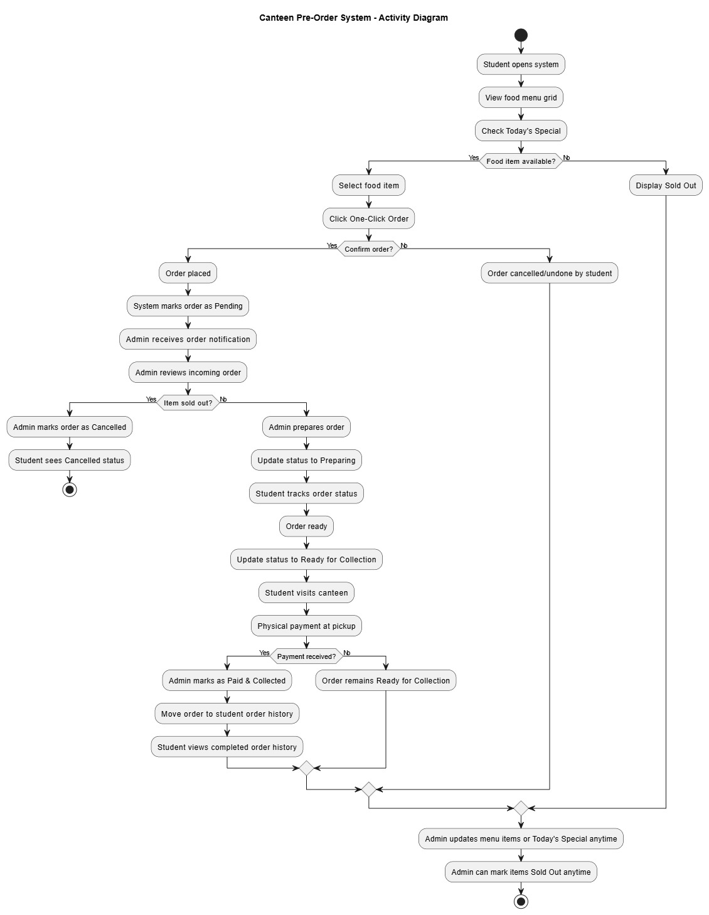
Figure 1: Activity Diagram
This activity diagram illustrates a Canteen Pre-Order System where a student browses the menu, checks for availability, and places a "One-Click Order" that an admin then reviews. Once the admin confirms the item is in stock and begins preparation, the student can track the status until it is ready for collection and physical payment at the canteen. The process concludes with the admin marking the order as paid and collected, though it also accounts for edge cases like cancellations due to sold-out items or student decisions, and allows the admin to update the menu at any time.

3.3.2 ER Diagram
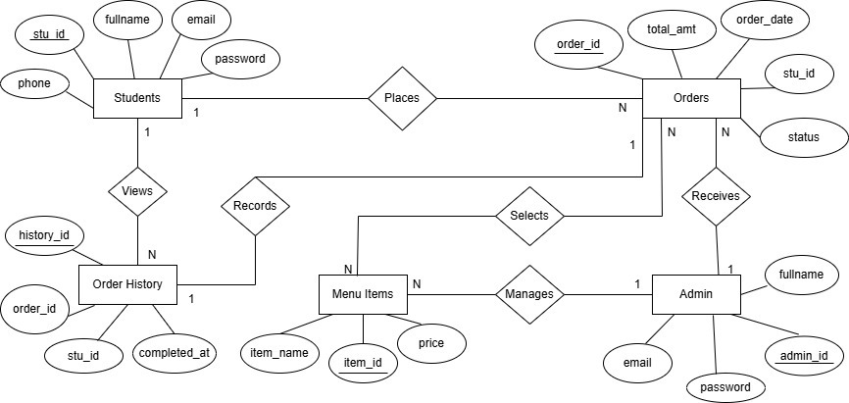
Figure 2: ER Diagram
This ER diagram shows the main entities of the Digital Canteen Pre-order System: Students, Orders, Menu Items, Admin, and Order History. Students place orders, select menu items, and view their order history. Each order stores student details, selected food, payment amount, and status. Admin manages menu items and receives student orders for processing. Completed orders are stored in Order History for future reference

3.3.5 Use Case Diagram
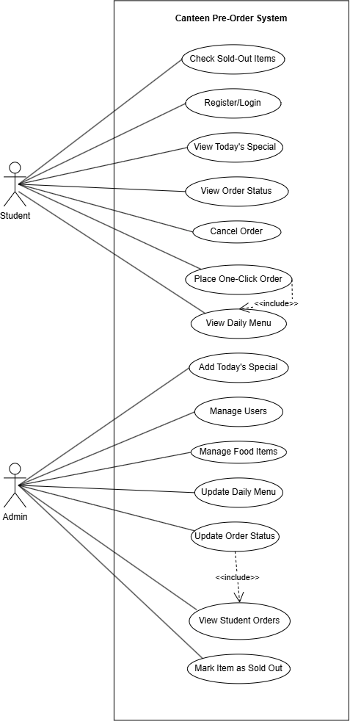
Figure 3: Use case diagram
This use case diagram illustrates how Students and Admin interact with the Canteen Pre-order System. Students can register/login, view the daily menu, check Today’s Special and sold-out items, place one-click orders, track order status, and cancel orders. Admin manages users, food items, daily menu updates, Today’s Special, sold-out status, and processes student orders by viewing and updating order statuses. It shows the core functionalities available to each user role within the system.

3.3.6 Sequence diagrams
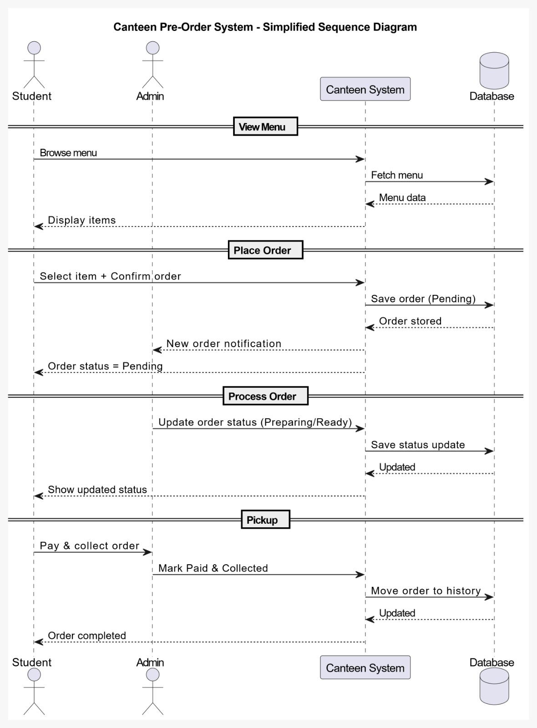
Figure 4: Sequence diagram
This sequence diagram shows the step-by-step interaction between Student, Admin, Canteen System, and Database in the Digital Canteen Pre-order System. First, the student browses the menu, and the system fetches menu data from the database. The student then places a one-click order, which is stored as pending and notified to the admin. The admin processes the order by updating its status to preparing or ready, and the student receives live status updates. Finally, during pickup, the student pays physically, the admin marks the order as paid and collected, and the system stores the completed order in order history.

3.3.7 Class Diagram
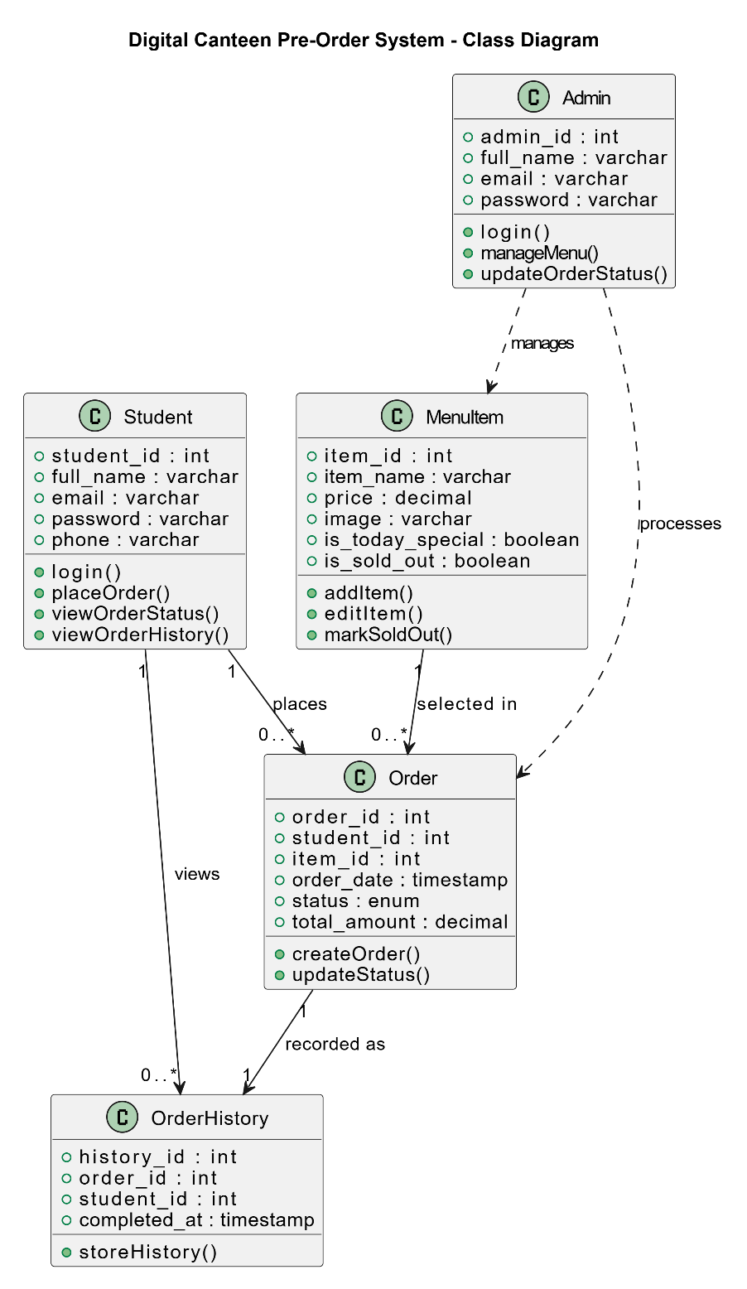
Figure 5: Class Diagram
The class diagram of the Digital Canteen Pre-order System represents the main system entities and their relationships. The Student class handles student information and ordering functions, while the Admin class manages menu items and order processing. The MenuItem class stores food item details such as price, image, and availability status. The Order class records student orders, selected menu items, total amount, and order status, whereas the OrderHistory class stores completed order records.

References
[1] Joshi, S., Kasaju, B., Karki, P., Aryal, S. K., & Chhetri, S. B. (2022, October). Smart canteen management system. In 2022 IEEE 2nd Mysore Sub Section International Conference (MysuruCon) (pp. 1-5). IEEE.
[2] Toma, S. T. F., Karmaker, D., Iqbal, S., Pantho, M. H. K., & Antara, R. S. I. (2021, December). Canteen Automation System: An Approach for “Smart City” Planning. In 2021 IEEE Asia-Pacific Conference on Computer Science and Data Engineering (CSDE) (pp. 1-6). IEEE.
[3] Narendran, A., Inuguri, A. H., Yashaswini, M., Sundaram, S., & Khanna, M. (2024, November). A Next-Gen Approach to Streamlined Canteen Management Systems using Mesa Framework. In 2024 8th International Conference on Computational System and Information Technology for Sustainable Solutions (CSITSS) (pp. 1-5). IEEE

